Cluster Analysis: Means

* Assessment of Clustering Tendency
  + Hopkins Statistic: 0.01
    - Since this is very close to zero, means data is highly clusterable
  + Visual Assessment of Clustering Tendency
    - 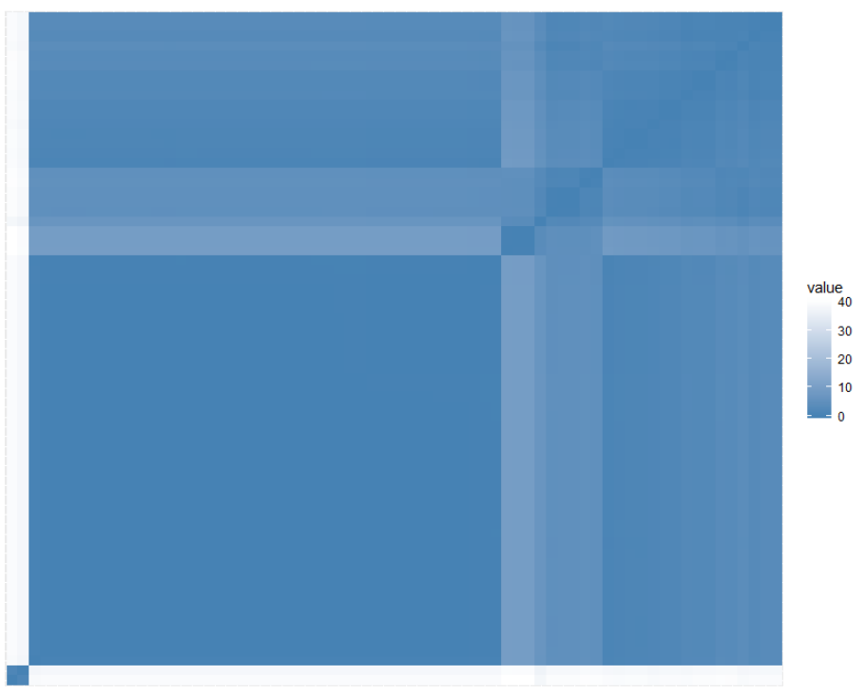
* Determining the optimal number of clusters
  + Silhouette method for hierarchical clustering
    - 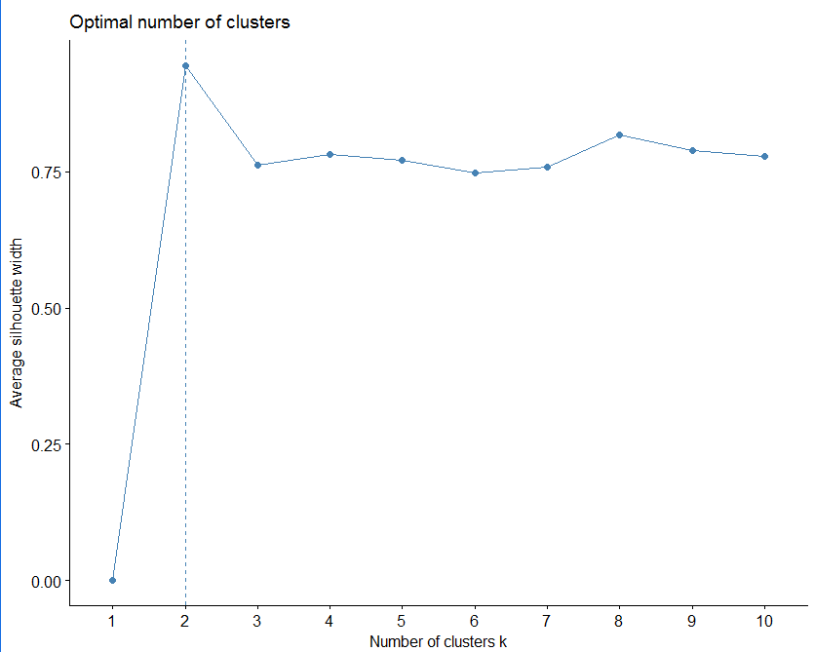
  + Gap statistic for hierarchical clustering
    - 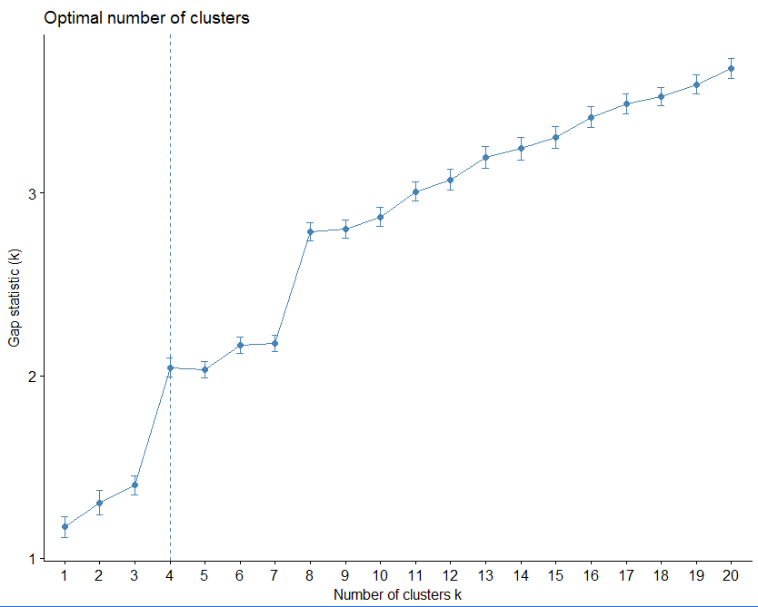
  + NBclust package: Provides 30 indices to determine best number of clusters
    - 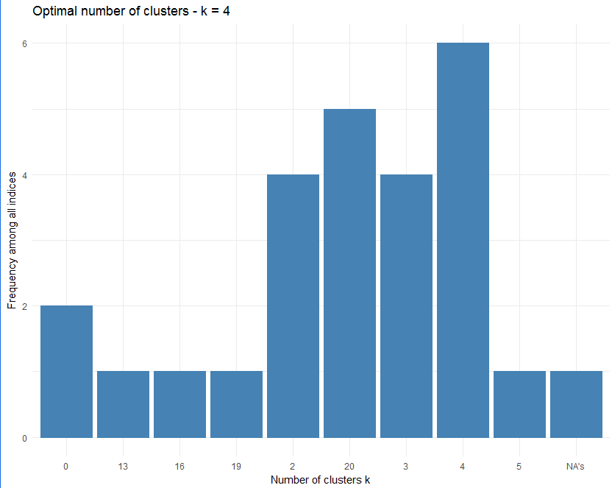
    - 
* Internal Validation
  + 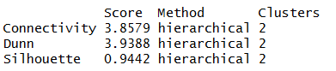
  + 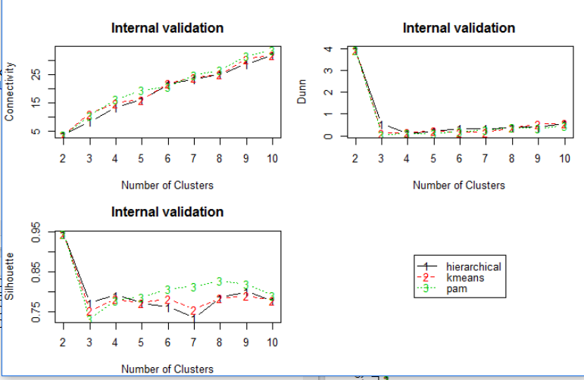
* Stability
  + 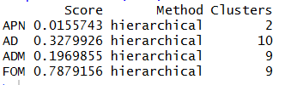
  + 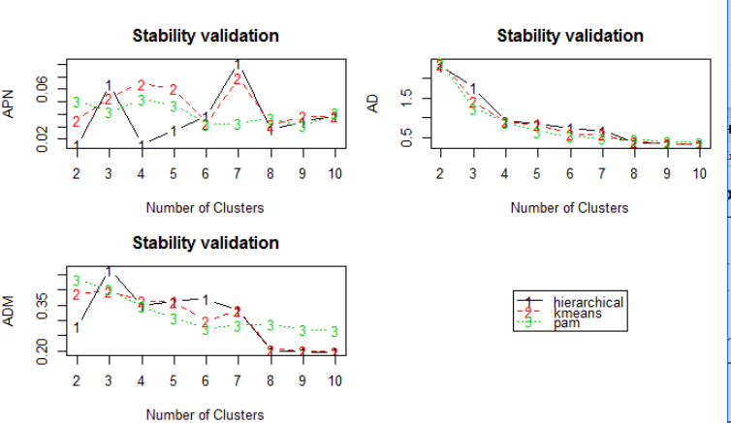
* Who is the overall winner?
  + 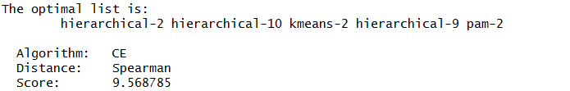
  + 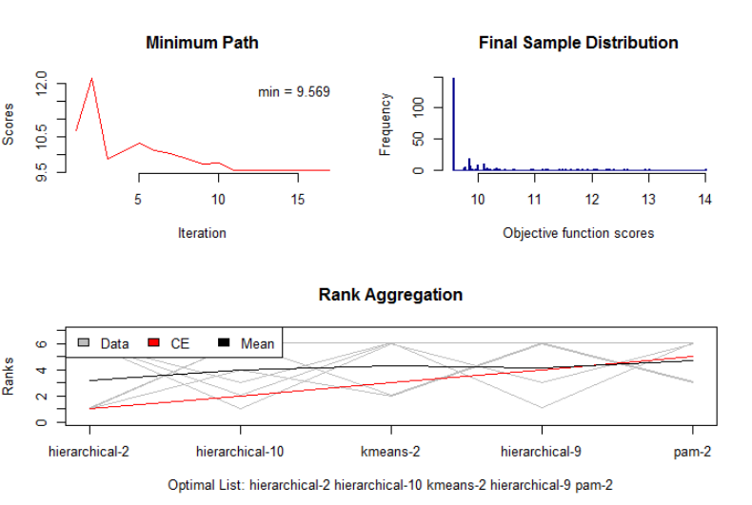

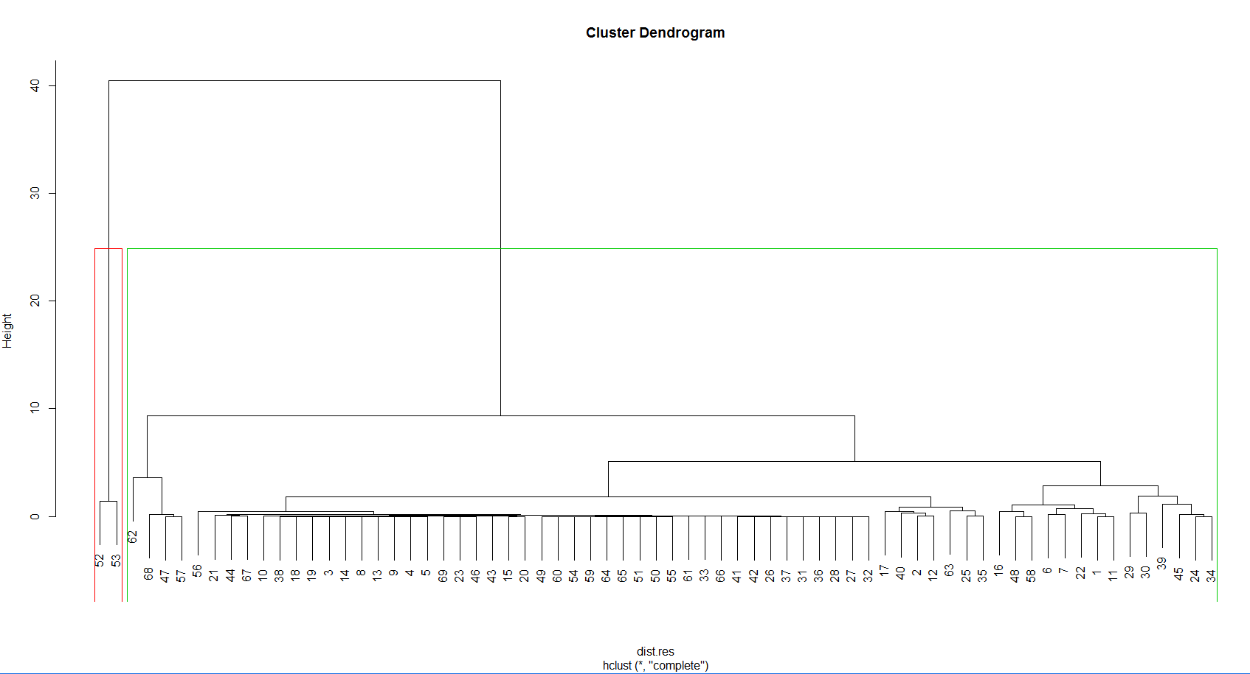

Cluster Analysis: SD

* Assessment of Clustering Tendency
  + Hopkins Statistic: 0.05
    - Since this is very close to zero, means data is highly clusterable
  + Visual Assessment of Clustering Tendency
    - 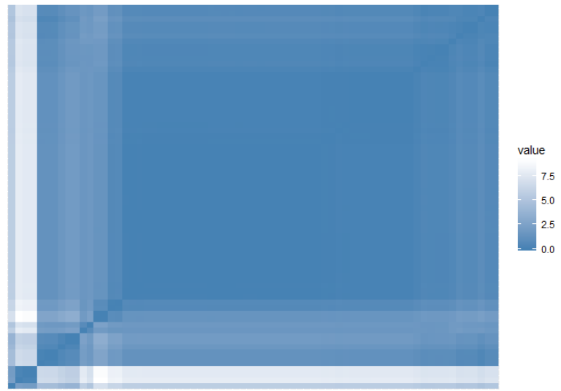
* Determining the optimal number of clusters
  + Silhouette method for hierarchical clustering
    - 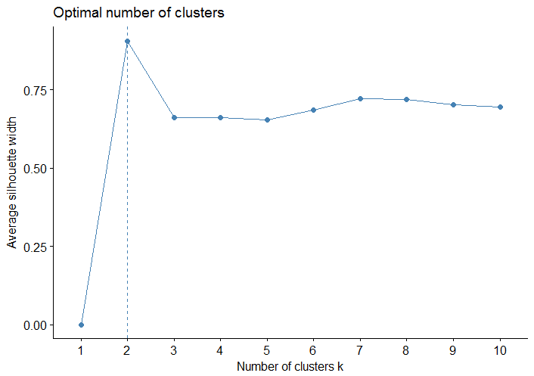
  + Gap statistic for hierarchical clustering
    - 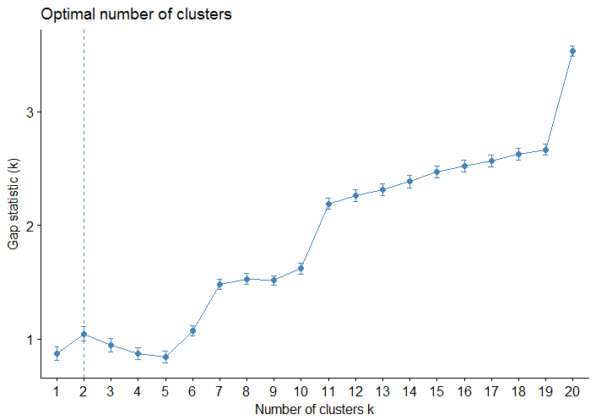
  + NBclust package: Provides 30 indices to determine best number of clusters
    - 
    - 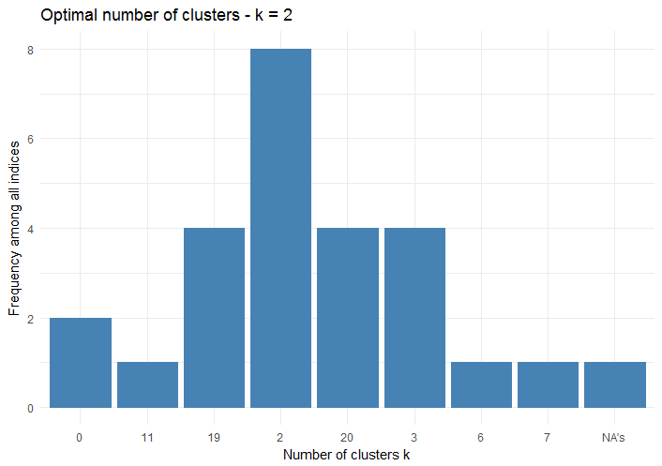
* Internal Validation
  + 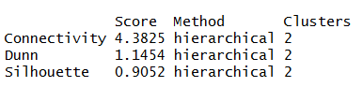
  + 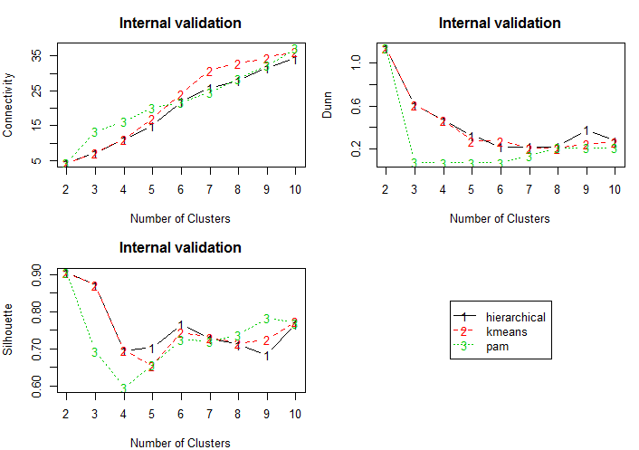
* Stability
  + 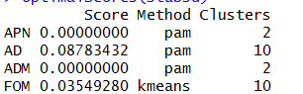
  + 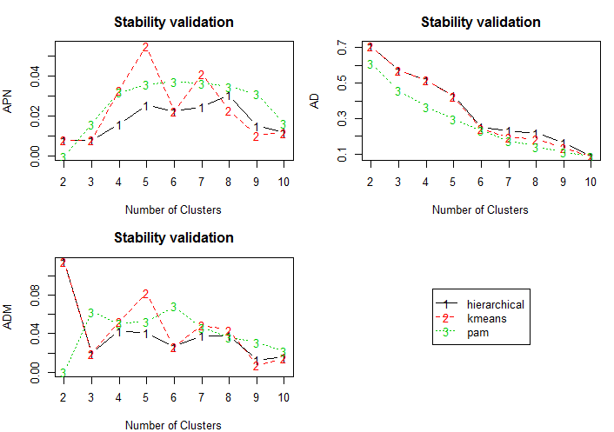
* Who is the overall winner?
  + 
   